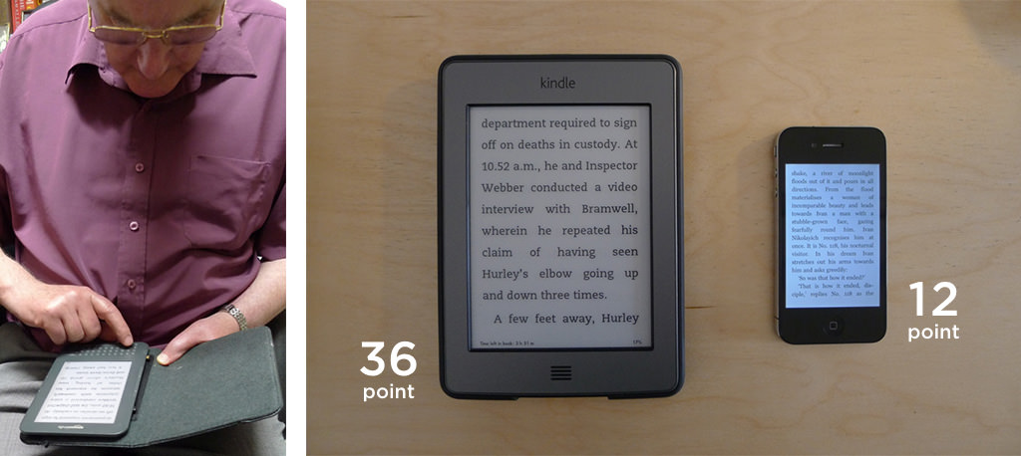

Zimmermann, G. & Vanderheiden, G. Accessible design and testing in the application development process: considerations for an integrated approach Univ Access Inf Soc (2008) 7: 117. <https://doi.org/10.1007/s10209-007-0108-6>

**Design for older and disabled people – where do we go from here? Newell and Gregor**

Designing a healthcare application has to consider the able bodied, the disabled, the elderly, and the *elderly and disable*d. The overall functionality of an elderly person is significantly different from that of the typical (young) disabled user. There is little evidence suggesting the elderly are technophobic; rather it is hard for them to understand and properly use such systems.

1. Sight impairment
2. Hearing impairment
3. Speech impairment
4. Mobility impairment
5. Dexterity and memory deterioration

Able-bodied and young people can simulate similar temporary impairments in noisy, poorly-lit and generally distracting environment.  
Inclusive design – make sure adapting design for disabled and elderly users does not compromise its functionality for non-disabled and young users.

Speech output/text-to-speech

# **Considerations for the Design of a Web-based Clinical Monitoring and Educational System for Elderly Patients.** *Demiris, Finkelstein, Speedie.*

Accessible design – maximising the number of potential users that can readily use the product.  
Functional limitation – reduced sensory, cognitive or moto capability associated with human aging, temporary injury or permanent disability that prevents a person from communicating, working, playing or simply functioning in an environment where most others can function.[1]

Aging affects information-processing capacity, reduces the speed of precise movements, increase the variance in timing. Increases the time required to recall information from memory and ‘thinking time’. Reduces ability to rapidly select needed information. Decreases attention span over long periods off time.   
Reading information, inputting data require visual and motor coordination many elderly no longer possess.

Interface considerations:

1. Simple and clear; concise, simple language
2. Alternative ways to access and navigate (allow for mouse/keyboard instead of touch screen or vice versa etc)
3. Icons should be simple, symbols designed to look like the object/function they represent
4. Large buttons with labels describing their function
5. Large font size (14+ point)
6. Avoid colour/patterned backgrounds
7. High contrast to ensure readability
8. Colour CANNOT be the only source of information as with age the ability to perceive colours may worsen
9. Dramatic differences in highly saturated colours to improve usability
10. A help menu with means of obtaining assistance in several ways
11. A clear navigation manual
12. Avoid sound effects unless necessary – may confuse elderly users
13. Eliminate distracting features such as pop ups or animations

**Investigating Usability Metrics for the Design and Development of Applications for the Elderly.** *Holzinger, Searle, Kleinberger, Seffah and Javahery*

“the elderly are often of the opinion that the benefits associated with computer use fail to outweigh the necessary effort.” Avoid using computer terminology – or very clearly define it.

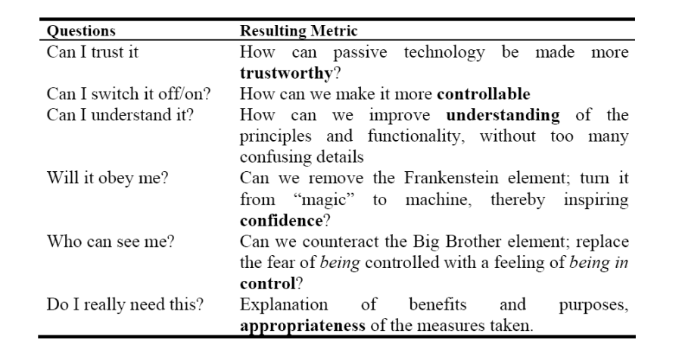

**Developing Websites for Older People:  
How Web Content Accessibility Guidelines (WCAG) 2.0 Applies**

1. Large text due to declining vision
   1. Allow text resizing
   2. Avoid putting texts in images that cannot be resized
2. Text style and layout
   1. Avoid fully aligned text or center-aligned text
   2. Use readable fonts
3. Colour and contrast
   1. Ensure contrast ratio of at least 4.5:1
   2. Information conveyed by colour differences also conveyed in text
   3. Light pastel background rather than white
4. Multimedia
   1. If Video and audio required, it should all have transcripts and captions available
5. Text-to-speech
   1. Provide short text alternative for non-textual content
6. Search function
   1. Provide search function to help users find what they need
7. Time
   1. Avoid time-constrained elements and functionality
8. Understandable language
9. Consistent style, navigation and labelling
10. Warnings
    1. Offer users information whenever a potentially confusing action is about to happen (pop ups and similar)
11. Refresh/Updates
    1. Elderly may not register the fact the content has been updated – they need some kind of confirmation that informs them.
12. Input assistance
    1. Describe in detail what information they need to provide
13. Error prevention
    1. Allow to revise and correct information before submitting

**Elderly User Evaluation of Mobile Touchscreen Interactions.** *Kobayashi, Hiyama, Miura, Asakawa, Hirose, Ifukube*

Non-touch Mobile phones:

* Hard to see displays
* Hard to press buttons
* Hard to learn procedures

Touch devices:

* Finger based intuitive interactions are useful regardless of age
* Touchscreen interfaces open up new possibilities for usable UI
* Two-handed touchscreen input too confusing
* Older users are somewhat slower in using gesture inputs, but there is no significant difference in accuracy

Their general findings are that basic touchscreen operations are easy for the elderly to perform without training – furthermore, a week’s practice will improve the performance. The simplest gesture, tapping, is the easiest to perform. Larger screens (tablet-sized) are preferred and more efficient for tapping, because the targets are larger, but the smaller screen is better for dragging and pinching operations, requiring smaller finger movements. Tapping small targets was much harder.

Design Implications:

1. Use large targets for tapping
2. Address the gap between intended and actual touch locations
   1. Elderly tend to miss their intended targets due to parallax and large contact area of fingers.

+SIMPLE

Platform designed especially for the elderly, digital tools for daily life. Consists off:  
- Culture (tours, museums, acitivies)

* Fun (games, movies, novels)
* Social networks
* +Simple manual, videos on how to use the app
* News
* Radio
* Health

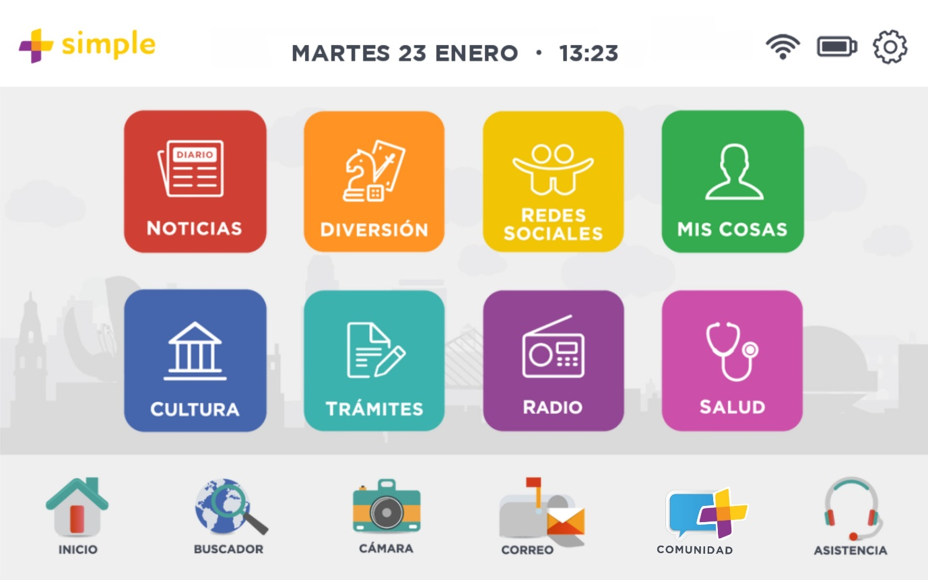

Either buy a tablet or use a tablet you already have

**A Study of Pointing Performance of Elderly Users on Smartphones.** *Hwangbo, Hee Yoon*

Button size and spacing is important for performance. As target size and spacing between targets increases, performance improves. Target performance was improved when target was in the upper and right direction from the centre (possibly as all participants were right handed). Designers should consider a layout with a right/upper-side arrangement for frequently used buttons for right-handed users, or the upper-side left for left handed users.

Tactile feedback alone did not improve performance – it could even be distracting and lower efficiency through losing grip on device. With audio feedback, performance slightly improved. However, a combination of the two, audiotactile feedback, yielded the best results and in discussion with test subjects was the most popular option.

**Touch panel usability of elderly and children** Chang, Tsai, Chang, Chang

While studies show touch panels are easy input devices for the elderly, usability testing shows that screen sizes can impact what can be achieved by the elderly. In general, an elderly person performance on a touch screen is much worse than young adults. However, when using gestures like pinch or rotate, the performance was not different across different age groups.

For small sized screens (such as a smartphone or tablet), elderly have difficulty performing drag and scale tasks – gestures on small screens should be avoided. A magnifying glass should be provided to aid their vision.

**Evaluating Touchscreen Interfaces of Tablet Computers for Elderly People.** *Burkhard, Koch*

In this study, the elderly participants expressed satisfaction in using touch screen devices and their preference was larger sized tablets that also weight little. Research found that touchable elements on the interface should not be smaller than 9mm in diameter to ensure accuracy in pointing. Dry or wrinkled fingertips proved challenging for some participants as it was less consistently recognized by the devices.

**Elderly Text-Entry Performance on Touchscreens.** *Nicolau and Jorge*

Tablet devices can compensate for about 9% off typing errors. The larger key sizes of tablets vs mobile phones increases accuracy somewhat. As some elderly experience shaking and tremor, this impacts typing and pointing performance. Whenever possible, elderly shouldn’t need to input text data, rather be given a selection to choose from. In spaces where alphanumeric characters are required (age, weight etc.) a small T9 keyboard is preferred.

**DESIGN THINKING**

* Empathy for the context of the problem (the customer, what their motivation is, what problem are we fixing)
* Creativity (lots of ideas of how to potentially solve the problem)
* Rationality (analyse ruthlessly which ideas actually solve the problem; doesn’t matter if we like them or not, what matters is that they solve the problem)

**LEAN UX**

Rapidly testing ideas.  
Prioritize learning over growth – test first, learn first, ship/scale later.

360 degree assumptions:

* Who is the customer, what problem are we trying to solve and what solution could work?
* What outcome does the customer want?
* How do we get the customer?
* Who will be the first customer?
* What’s the business s model?
* Who are the competition?
* What makes us better than the competition?

Take those questions, turn them into hypothesis:  
“We believe that   
[building this feature]  
[for these people]  
will achieve [this outcome].  
We will know we are successful when we see [this signal from the market].

https://www.usability.gov/how-to-and-tools/methods/card-sorting.html

1.